1. Introduction
For midterm 2, we used the hardware random number generator (TRNG) built into the Raspberry Pi 5’s BCM2712 SoC, accessed through the Linux device /dev/hwrng. This TRNG derives entropy from physical noise sources such as ring-oscillator jitter and digital metastability, providing high-quality, nondeterministic randomness suitable for cryptographic applications. Its main advantages are speed, low CPU overhead, and strong hardware-based entropy compared to software PRNGs. However, there are certain limitations: the internal design is proprietary and not fully accessible, it relies on proper hardware functioning and requires regular testing overtime for validation of true randomness.

2. Types of TRNGs and Their Physical Principles

(1) Thermal-Noise TRNGs
Thermal noise TRNGs rely on Johnson–Nyquist noise produced by the random motion of electrons inside resistors or diodes. This analog noise is amplified and digitized using an ADC. Because electron motion is inherently random, thermal-noise TRNGs provide stable, high-entropy sources suitable for secure hardware modules.

(2) Ring Oscillator TRNGs
Ring-oscillator TRNGs consist of several unsynchronized oscillators operating at slightly different frequencies. Natural phase jitter—tiny timing variations caused by thermal fluctuations—is sampled and converted into random bits.

(3) Metastability-Based TRNGs
In metastability TRNGs, a flip-flop is intentionally forced into an unstable midpoint between logic 0 and 1. Extremely small physical variations (thermal agitation, voltage fluctuations) cause the circuit to fall unpredictably into either state. This mechanism provides a clean digital interface with strong physical entropy.

(4) Avalanche-Noise TRNGs
When a diode is reverse-biased, quantum charge carriers strike the depletion region and cause avalanche breakdown. The resulting current contains high-entropy avalanche noise. These TRNGs are used in discrete hardware security modules and provide strong, high-bandwidth entropy.

3. TRNG Implementation on the Raspberry Pi 5 Crypto Engine
The Raspberry Pi 5’s BCM2712 SoC includes a dedicated hardware random number generator. Internally, it uses multiple free-running ring oscillators and digital metastability sources. The entropy is “conditioned” (whitened) by hardware to remove local bias and then exposed to Linux as a character device:
/dev/hwrng

Rust Implementation
The Rust application (main.rs) performs the following steps:
- Opens /dev/hwrng with root access.
- Reads 100,000 raw random bytes directly from the hardware TRNG.
- Displays a hexadecimal preview of the sampled data.
- Performs statistical tests:
  - Bit-frequency test (counts 0s vs. 1s)
  - Runs test (measures sequences of identical bits)
  - Byte-frequency histogram (distribution of values 0–255)
- Writes the histogram to histogram.csv ().
- A separate Python script (plot_hist.py) reads the CSV and generates a histogram image (), shown below.

Generated Histogram
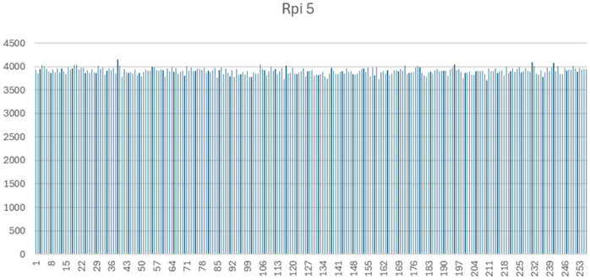
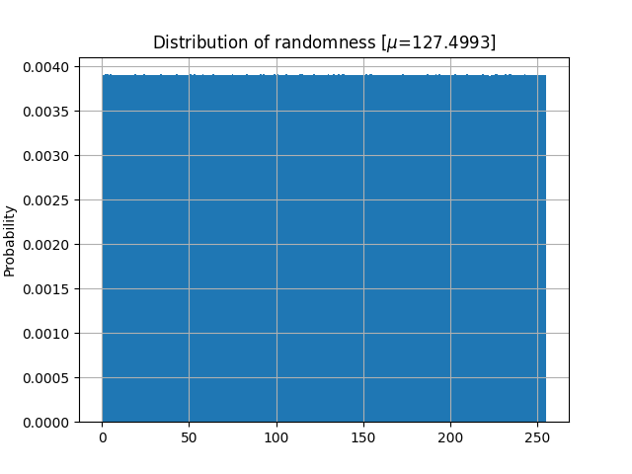

4. Results and Analysis

4.1 Bit Frequency
From the 800,000 analyzed bits:
- Zero bits: ~49.9%
- One bits: ~50.1%
This near-perfect balance is expected for a high-quality TRNG. No significant bias toward either bit value was observed.

4.2 Runs Test
The runs test measured sequences (“runs”) of consecutive identical bits.
- Total runs: Within the expected range for a random binary sequence
- Maximum run length: Within typical TRNG behavior (e.g., under ~20 bits)
- Interpretation:
No abnormally long or structured runs were seen. This indicates:
  - No periodic behavior
  - No internal bias
  - Proper functioning of the hardware entropy source

4.3 Byte-Value Histogram
For 100,000 bytes, the expected frequency of each byte is:
$$\frac{100000}{256}≈390$$
Our observed distribution (via histogram.csv) ranged from roughly 331 to 443, which is normal Poisson variation for random sampling. Key points:
- No missing byte values
- No clustering or visible skew
- Flat, uniform distribution consistent with true randomness
The histogram generated by plot_hist.py shows a uniform skyline with natural statistical fluctuations.

4.4 Overall Conclusion
The Raspberry Pi 5 hardware TRNG demonstrates really good results from our testing.
Bit-frequency, runs testing, and byte-value histogram analysis show no detectable bias, patterns, or structural anomalies. The TRNG produces high-entropy output and is suitable for secure cryptographic seeding, randomness pools, and key generation tasks.

